Agenda for June 18th:

Due today: “My Story”

My Story video: “Turning Point”  
What connection can you make with this video?  
Can you write your story? What aspect will you choose to write about? Has there been a turning point in your life? Write about it.  
Challenge your mentee to find the oldest person he/she knows and **interview** her. Come back to you with his/her story.

Which one of these terms are you using with your mentee as you read your picture book?   
How can you explain the term “inference” so your mentee understands its usage through the picture book which you have?

Let’s do some review:

Break into 5 groups and discuss:

What reading rules have been covered so far? (See competencies for Rdg 091.)  
Can you explain the rule to your group?   
Can you find an example of the rule from the book you have today?

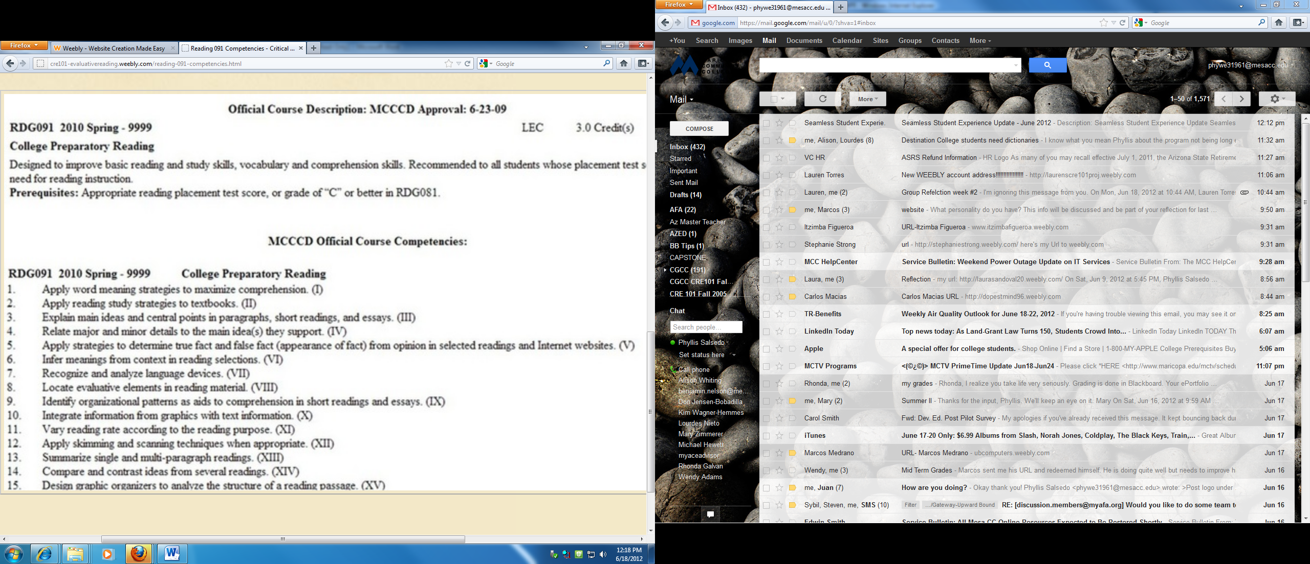

Incorporate into lesson tomorrow or Thursday.

Reading skills to be taught before end of term.

Word of the Day from Day 1 to today? What are they? Definitions?  
What words did you have your mentee learn and define?  
Share with your group.

**Be ready to present to class.**

Type up your results and submit as a group reflection. This is Reflection #2.

What should we do this week?

What reading rule might be covered if you had the time? Is there another issue which you want to identify for your mentee to explore this week?