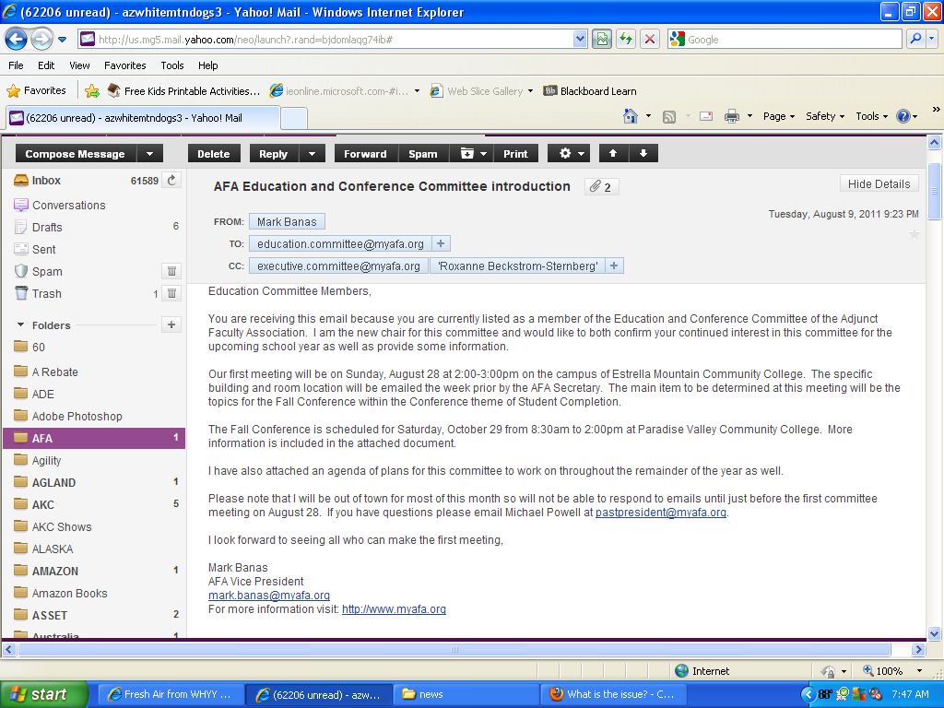
AFA Education and Conference
FY 2011-2012 Agenda

- Conference
- Fall Workshop – Saturday, October 29
- PVCC pending confirmation, 8:30am – 2:00 pm
- Speakers – Dr. Rufus Glasper & Dr. Maria Harper-Marinick
- Theme: Student Completion
- Structure/Sessions

- Spring Conference – Saturday, April 14/21/28
- Location & Time TBA
- Potential Speaker – Dr. Jill Biden, Rep. Jeff Flake, (other options)
- Theme: Back to the Basics
- Structure/Sessions

- AFPG – Adjunct Faculty Professional Growth
A. Substitute pay for attending professional growth events during class sessions
B. Create event listing database sorted by subject area and department cross-listed
C. Publish travel awards on AFA website
D. Require written AFPG follow-up experience

- District-level Training Opportunities
A. MCLI – Maricopa Center for Learning and Instruction (academic)
B. EOLT – Employee and Organizational Learning Team (human resources)
- Resume writing
- Interviewing

- AFA Recommended Professional Development
A. Create an AFA recommended professional development path for adjuncts
B. Structure/components
C. Decide how to implement and/or publish

AFA Fall Workshop 2011
Saturday, October 29, 8:30am – 2:00 pm

Location:
PVC, pending confirmation

Keynote speakers:
Chancellor Dr. Rufus Glasper, (topic?)
Vice Chancellor Dr. Maria Harper-Marinick, Student Completion

Theme:
Student Completion

Tentative Schedule:
7:30 – 8:30 | Set-up (signage, tables, registration, etc.)
8:30 – 9:00 | Registration & Continental Breakfast
9:00 – 9:20 | Welcome (AFA VP) & AFA Presidential address
9:20 – 9:50 | First keynote speaker
9:50 – 10:00 | Break
10:00 – 12:00 | Sessions TBD by Conference Committee
12:00 – 12:45 | Lunch
12:45 – 1:15 | Second keynote speaker
1:15 – 2:00 | College dialogues on Student Completion with AFA College Rep and College Presidents and/or VPAA’s
2:00 | Closing Remarks
2:15 – 3:00 | Debrief with AFA board, clean up, go home

Session Structure:
Two breakout time periods of 50 min each with 10 min break in between. 3-4 sessions for each breakout. Session topics can either be repeated for both time periods or we can have 6-8 different topics so no topic is repeated.

Session possibilities:
Textbook Reading Strategies, Rubric Design, the “no lecture” class, cooperative learning, First time adjuncts, technology?

