Today, July 12th
Ch. 4
*Ch. 4 reading/questions | Meet w/me  Ch. 4 Discussion
Hannah  Use a computer on the north side of the room, please. | Marisa  Earn 80% on tests for all 3 areas regarding the main idea, implied main idea, and supporting details before Tues.
Elizabeth | Aaron
 | Sarah
 | Jama
 | James
 | Sheila
 | Raquel
 | Dale
*1. Choose a reading from pages 187-220 (Read article, do Skill Development, Comprehension, and Vocab for reading.
2. Correct your work with my textbook.
3. Work on assignments which are due Monday.
Assignments due Monday before 9:20: (Submit as docs in Bb.)
  - Analyze what you have learned about yourself. Reflection #1
  - Weekly Schedule
  - Set up a lesson to share with your buddy on “Main Idea”, “Implied Main Idea”, or “Supporting Details”
    - Show me your worksheet before end of class.
  - Submit first formal Reading Log lesson to Bb.
  - Go to your Study Plan and take the following tests before end of class, if possible. (No later than 9:20 Monday morning.)
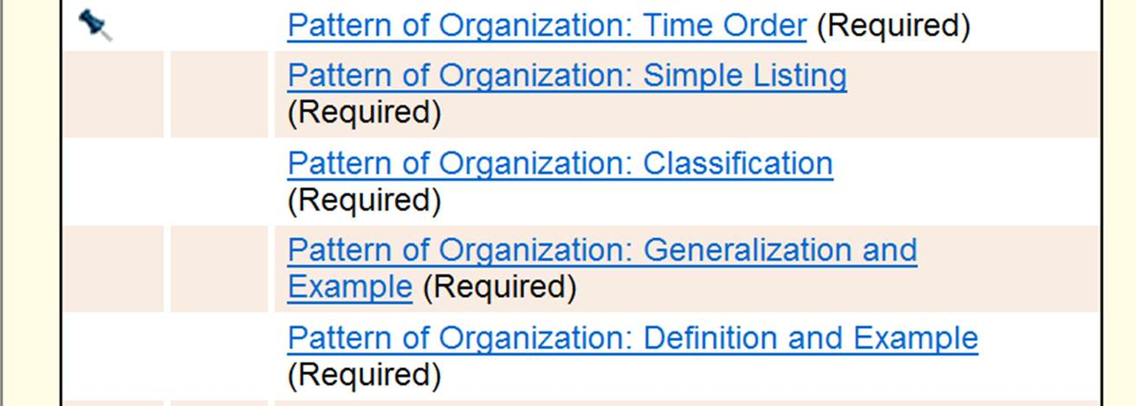
1
2
3

4
5

3 tardies = 1 absence
3 absences = possible withdrawal

