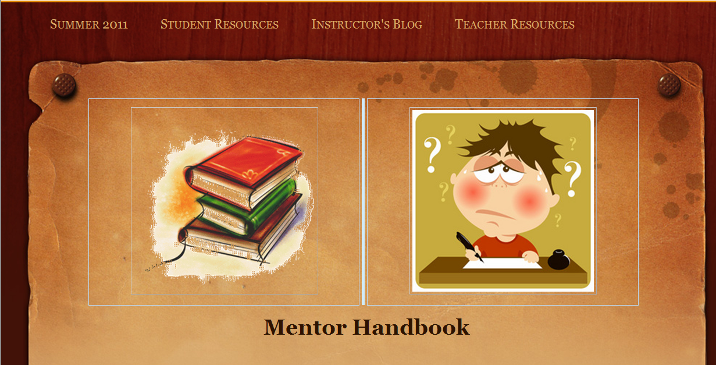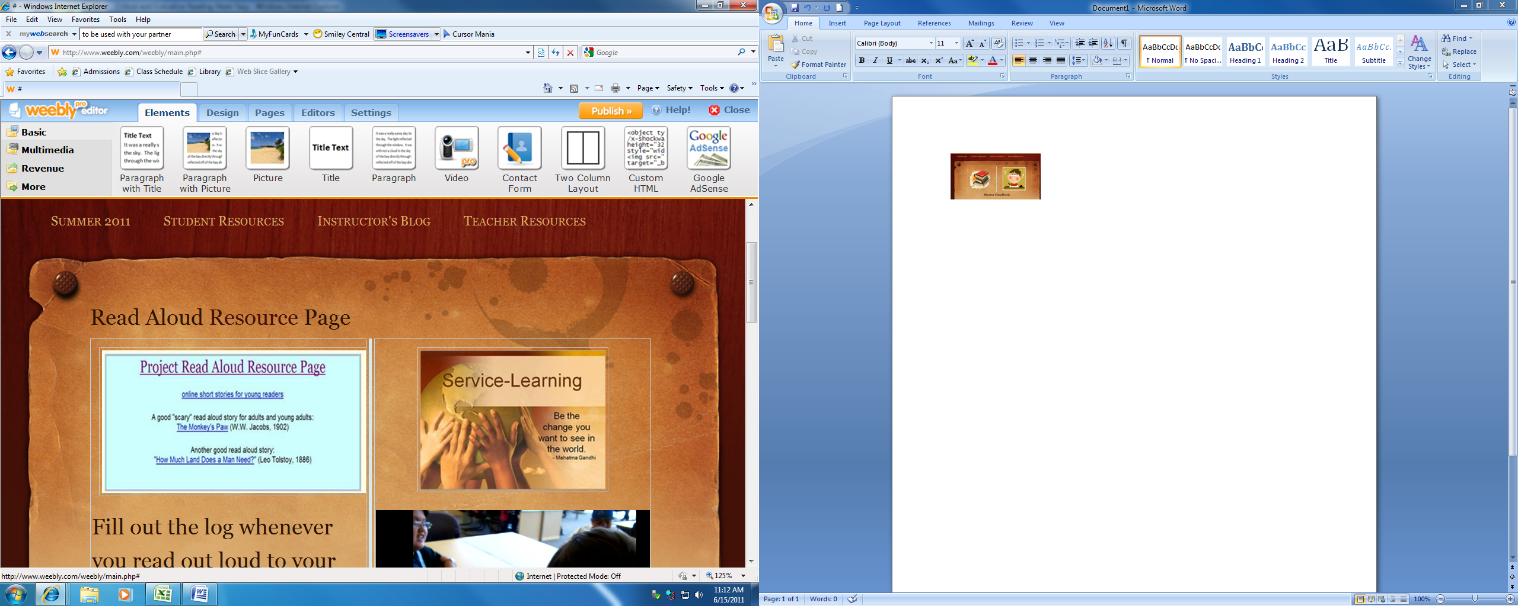
Mentor Handbook
Project Read Aloud
ePortfolio
First, create your website. Example, weebly.com.

- Lesson Plan  a. Agenda – Be specific:  i. Script of what you did minute by minute for each lesson.    ii. Vocabulary words (5-10)  iii. Comprehension Checkup  iv. Reading Skill Focus  iv. Materials:  (1) picture book info  - Reflection – Group, how did it go? Discuss and reflect.  - Which reading did you do for each part of the textbook in order to prepare to meet with your student(s)? See agenda.  - Did you check your answers for the reading with the instructor’s textbook? | - Log for each session. (At least 4.)  - Report (Oral Presentation given during last week of class.) | - Reflections (at least, weekly)  a. Specific information as often as is possible.  i. What did you learn from each chapter? Present facts + opinion about each.  - Reading Summary with Comprehension Checkup results.  - Copies of each Chapter “Score Results.”
^{REMEMBER:} Give credit where credit is due when referring and giving facts or paraphrasing those facts.

